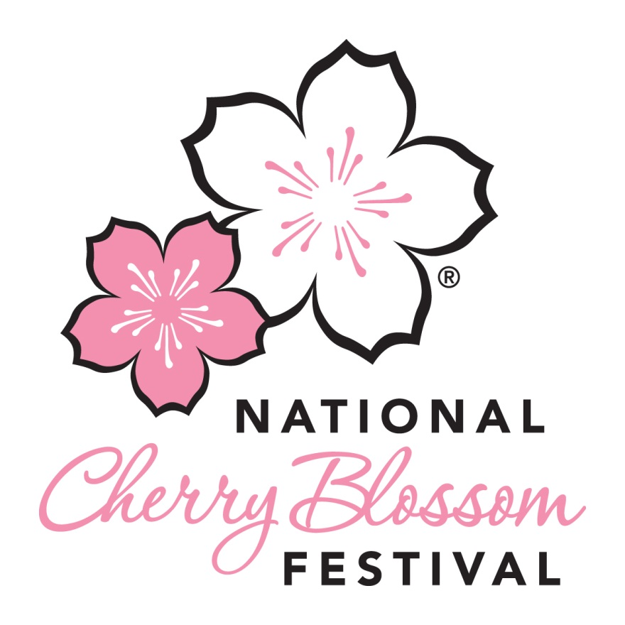

BLOSSOM KITE FESTIVAL
Saturday, March 28, 2015
Rain Date: Sunday, March 29, 2015

CONTACT: Elissa Staley, 301-467-9033 (cell)
elissa@downtowndc.org

Thank you for participating in the National Cherry Blossom Festival’s Blossom Kite Festival.

For the programmed activities and schedule of the festival, please visit:
http://www.nationalcherryblossomfestival.org/blossom-kite-festival-3/

EVENT TIMES: 10:00 am - 4:30 pm

The Festival is RAIN OR SHINE. If there are any safety concerns due to severe weather or a downpour of rain, a decision will be made by 5:00 am. Please check the Festival website for current information for updates. If there is rain during the event, we will work around the rain showers and continue the event when weather permits. Be prepared for rainy conditions and bring your own tarps or other items to protect your belongings.

SET-UP TIMELINE:

Festival staff will be on-site early in the morning and coordinating the load-in of various vendors. Field set-up will be completed the day before.

8:00 am
- Those with an activity tent or display may arrive to load into their area.
- Prepare to unload your materials in the designated loading area on Constitution Ave. and then park your vehicle.
- If you need more time, feel free to arrive early.

9:30 am
  - All set-up of activities, exhibits and tents should be complete.

LOAD-IN:
Ensure you give yourself adequate time to arrive on site. Remember to bring hand trucks or carts on wheels to assist with load-in.

If you need to unload a significant amount of materials, please pull up to the loading area located at the corner of 17th and Constitution, unload, and then find parking elsewhere. Event parking on Constitution Avenue is reserved for selected vendors and participants only. Unless you have been informed that you will have a parking pass, please plan to make other arrangements for parking.

After loading, you can park your vehicle on neighboring streets or in a garage. Please note that on Saturdays the metered street parking may be very limited. Please read meters and signage carefully.

IMPORTANT: Please note that driving on the walkways is for vendor trucks only and driving on the grass is strictly prohibited. All personal vehicles are strictly prohibited from driving onto the event site.

A Few Suggestions on Area Parking Garages*
Colonial Parking
515 20th St NW
Between E and F Streets
Colonial Parking
814 20th St NW
Between H and I Streets
Note: Does not opens until 9:00am

Colonial Parking
950 22nd St NW
Between I Street and Pennsylvania Avenue

LAZ Parking
1721 I St NW
Between 17th and 18th Streets
* Please note that these are a mile or less away, and may require a decent amount of walking. Feel free to investigate other options!
METRO: Use of Metro is encouraged whenever possible. Smithsonian Metro, Farragut North, and Federal Triangle (Orange/Blue) are the closest to the site. Please leave time to walk from the Metro to the event site.

CAPITAL BIKE SHARE: There are multiple Capital Bike Share stations located near the event site. Please visit http://www.capitalbikeshare.com for more information and station locations.

DURING THE EVENT:
- First Aid located next to the Festival Operations tent.
- Please escort lost children to Festival Operations tent.
- Only educational information can be distributed on National Park Service land. Advertising for a commercial entity is prohibited.

LOAD OUT TIMELINE:
4:30 pm
  - The Festival ends and vendors may start breaking down equipment.

BEFORE YOU LEAVE:
  - Please clean your area of trash so that we leave the National Mall in good condition after the event.

Thanks again for being a part of this great tradition of flying kites in the spring!



